SOFTWARE TESTING METHODOLO HW 7 TinyDB Evaluation Test

In this assignment I will test tinyDB driver some operations.

case 1 search existing data by valid query

case 2 insert data by valid query

case 3 modify existing data by valid query

case 4 delete existing data by valid query

case 5 search Non-existing data by valid query

case 6 modify Non-existing data by valid query

case 7 Delete Non-existing data by valid query

case 8 can not insert exits data

Test Result:

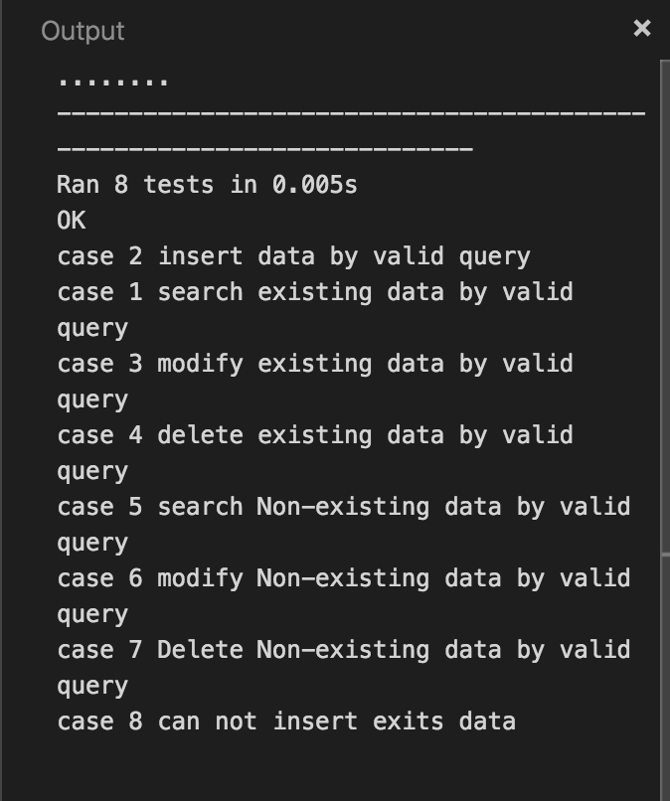

Codes:

